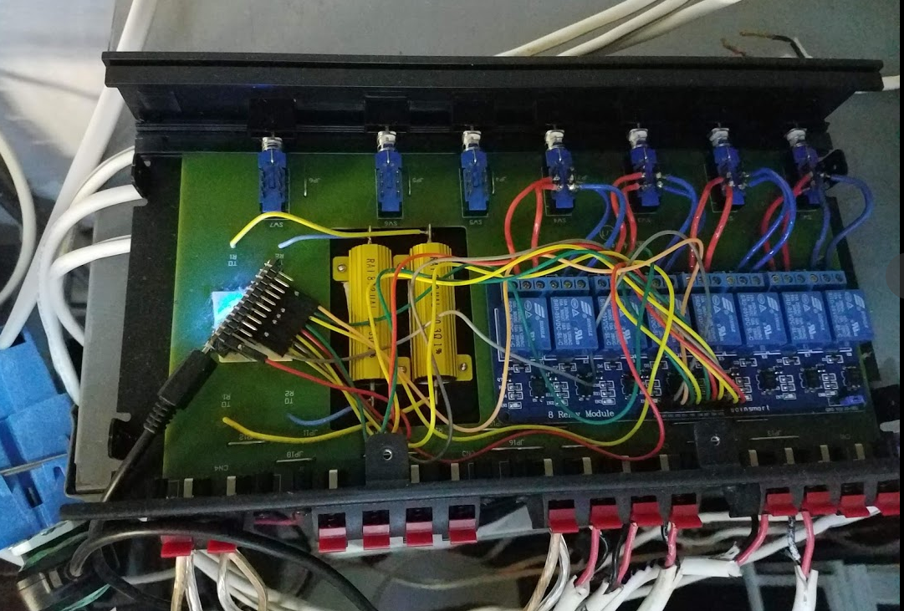

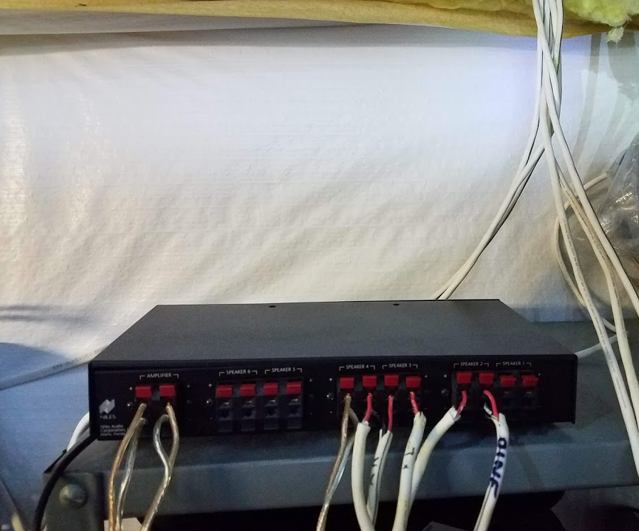

MakerFocus 2pcs ESP8266 NodeMcu Serial Wireless Arduino Wifi Module CH340 NodeMcu Arduino V3 Lua WIFI IOT Development New Version Esp8266 Development Board For Arduino Project

<https://www.amazon.com/gp/product/B01N8UUE3L>

<http://nodemcu.com/index_en.html>

**ESP8266 NodeMcu Features**

* **USB-TTL included, plug&play**
* **10 GPIO, every GPIO can be PWM, I2C, 1-wire**
* **FCC CERTIFIED WI-FI module, PCB antenna**

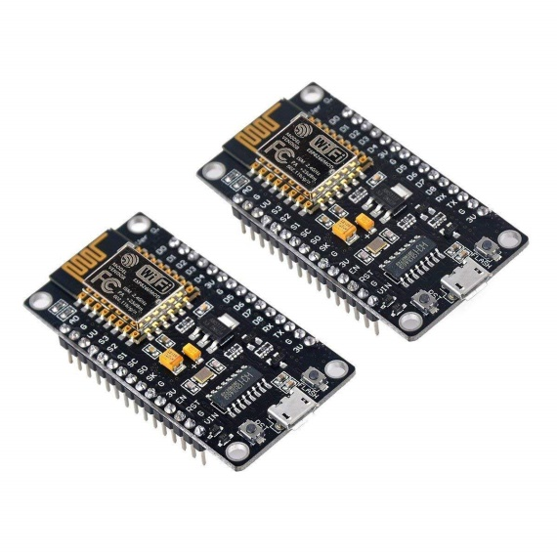

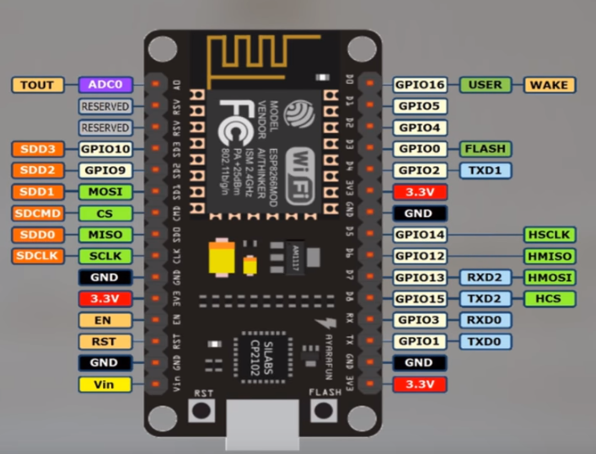

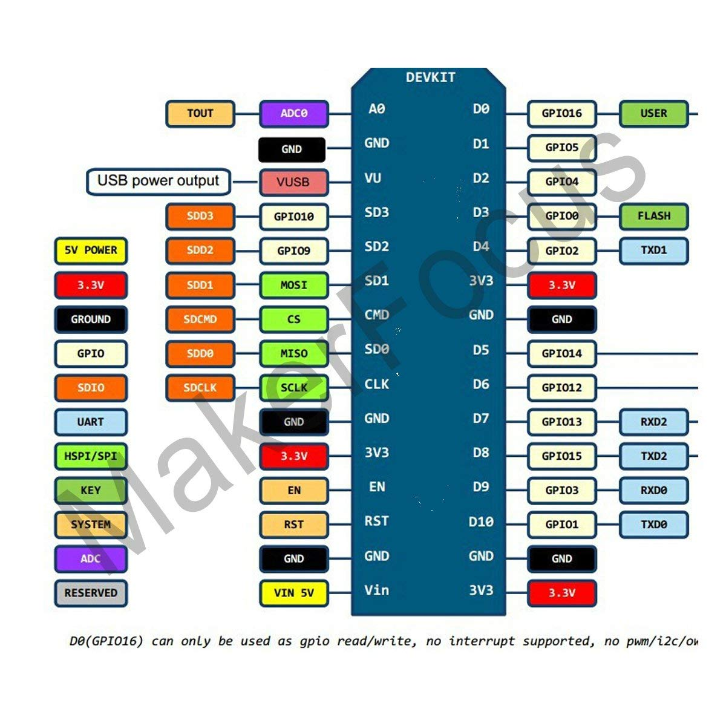

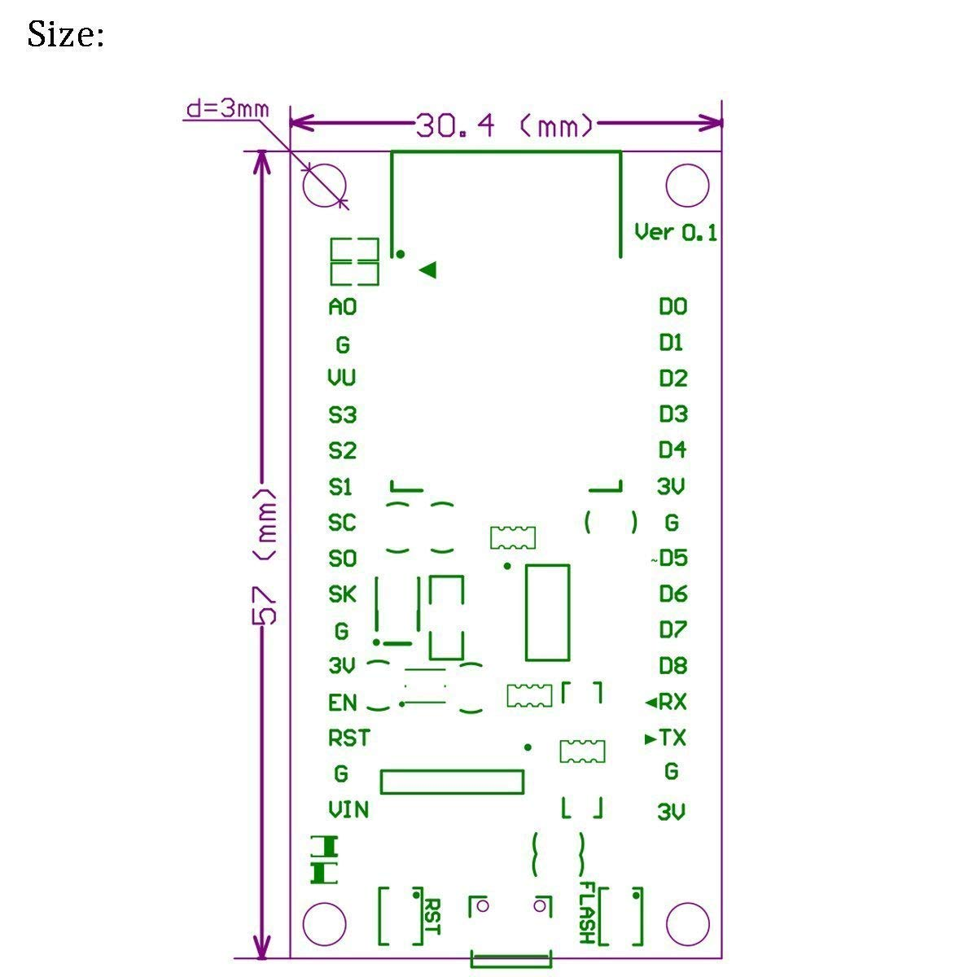

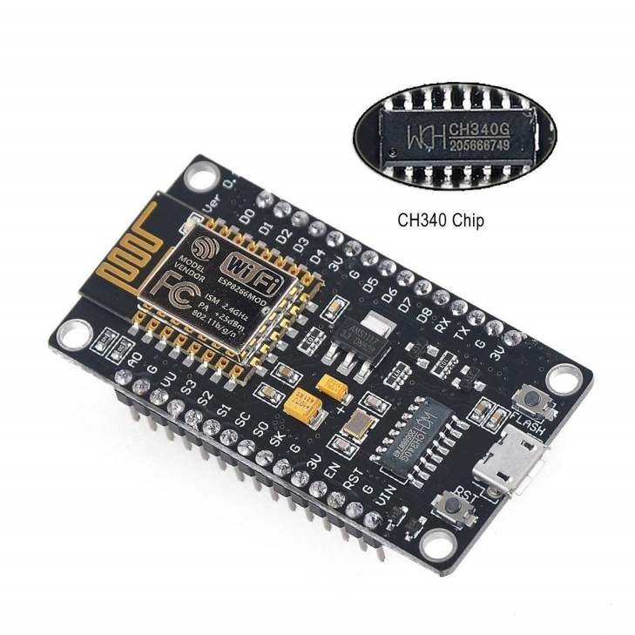

Setup and Programming

* <https://www.youtube.com/watch?v=NEo1WsT5T7s&t=7s>
* <https://www.youtube.com/watch?v=p06NNRq5NTU>
* <https://www.youtube.com/watch?v=sNLA0MF5cOY&list=PLfPtpZzK2Z_Qy2ZbbzvWa58cKKOisMUZ1&index=3>

1. Install **CP210x USB to UART Bridge VCP Drivers** [**https://www.silabs.com/products/development-tools/software/usb-to-uart-bridge-vcp-drivers**](https://www.silabs.com/products/development-tools/software/usb-to-uart-bridge-vcp-drivers)
2. Use Arduino IDE
3. Add ESP board to IDE
   * File -> Preferences
   * At this to Additional Board Managers URL:

<http://arduino.esp8266.com/stable/package_esp8266com_index.json>

* + Restart IDE

1. t